Practice debug questions
- C++ program to extract the domain name from an email address using string functions.

(For example, if input = student@somaiya.edu, the output should be Domain: somaiya.edu)

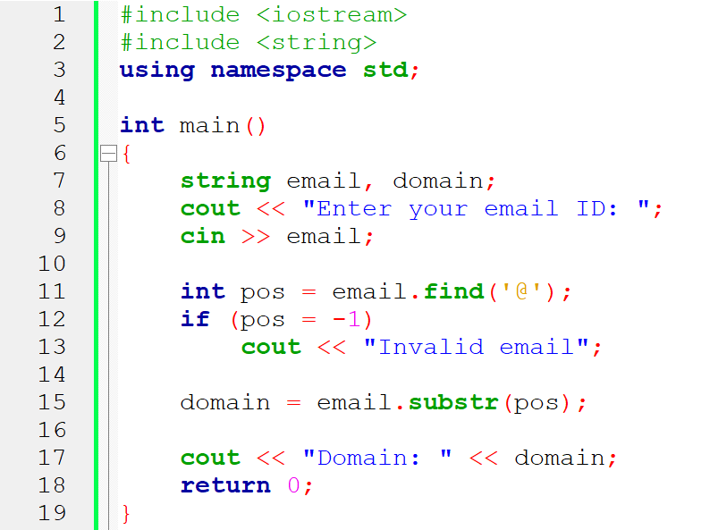

Line no | Error | Explanation | corrected code | marks
11 | Type | find() returns size_t not int | size_t pos = email.find('@')
12 | Logical | Assignment = used instead of comparison == | if (pos == string::npos)
15 | Logical | substr(pos) includes the '@' symbol | email.substr(pos + 1)

- C++ program to read n words and print how many of them start with a vowel.
If none of the words start with a vowel, print "None".

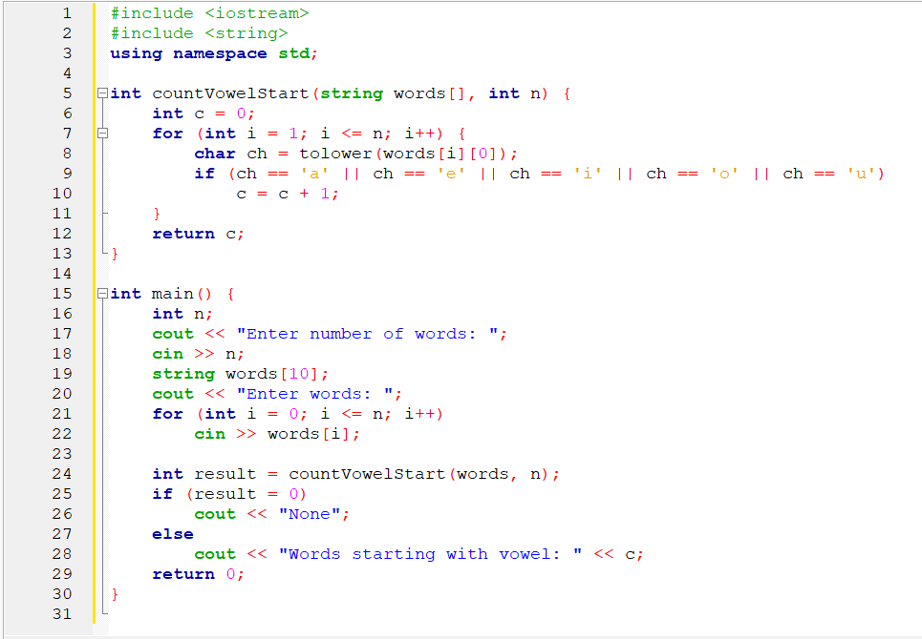

Line no | Error | Explanation | corrected code | marks
7 | Logical | Loop should start from 0 and run < n | for (int i = 0; i < n; i++)
21 | Logical | Loop reads one extra word (<= n) | for (int i = 0; i < n; i++)
25 | Logical | Assignment = used instead of comparison == | if (result == 0)
28 | Error | Printing undeclared variable c | Use result

- C++ program to find the sum of the first N numbers using recursion.
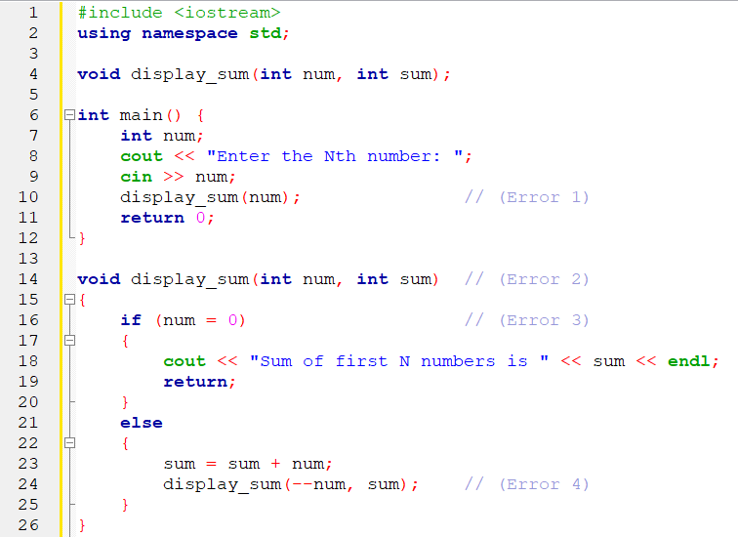

// hint given in the question

- Write a program to perform matrix multiplication

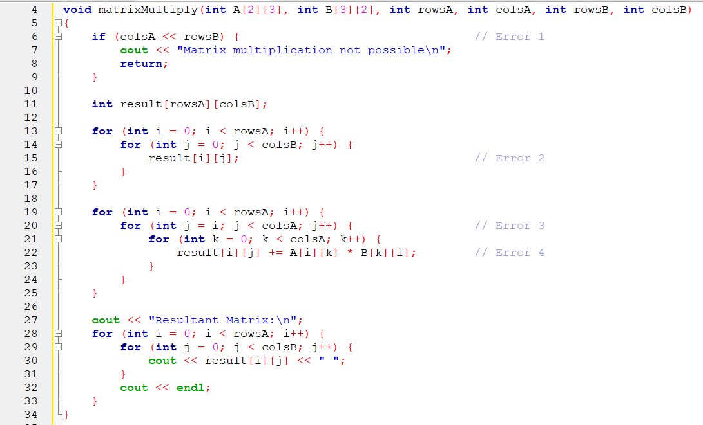
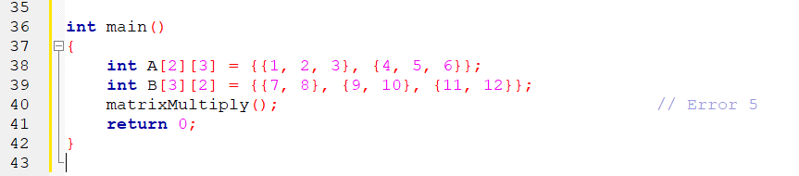

Solution:

Line no | Error | Explanation | corrected code | marks
6 | Logical/syntax | Used << (bitwise left-shift) instead of comparison operator | if (colsA != rowsB) | 2
15 | Logical | result[i][j]; does nothing — must initialize to 0 | result[i][j] = 0; | 2
20 | Logical | j = i limits columns; should start from 0 and loop till colsB | for (int j = 0; j < colsB; j++) | 2
22 | Logical | Used B[k][i] instead of B[k][j] - wrong multiplication | result[i][j] += A[i][k] * B[k][j]; | 2
40 | Syntax | Missing arguments in matrixMultiply() call | matrixMultiply(A, B, 2, 3, 3, 2); | 2

